Including 5 web pages: home, resume, interest, guestbook and reflections.

All web pages have a navigation bar which when the screen is less than 600px, it will be a “hamburger” navigation bar. In “hamburger” mode, the .js file helps decide which state it will be (either active or not-active) and when active, it will show a drop-down list of the 5 web pages.

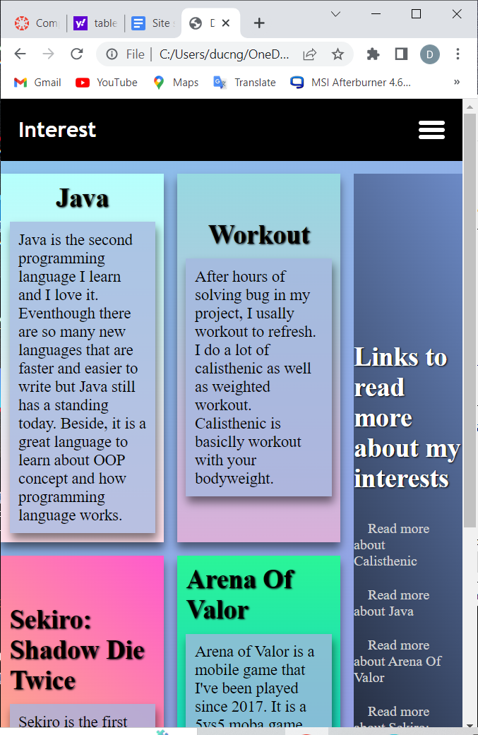

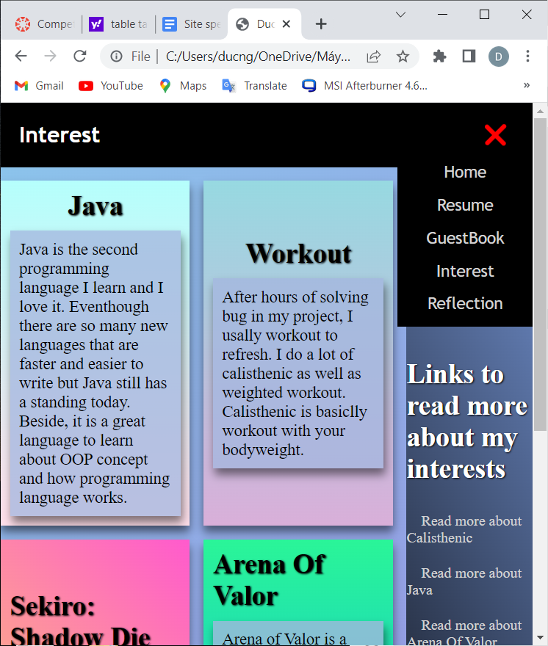

Home page: When hovering each tabs, the tabs will scale up so the reader will easily read the content

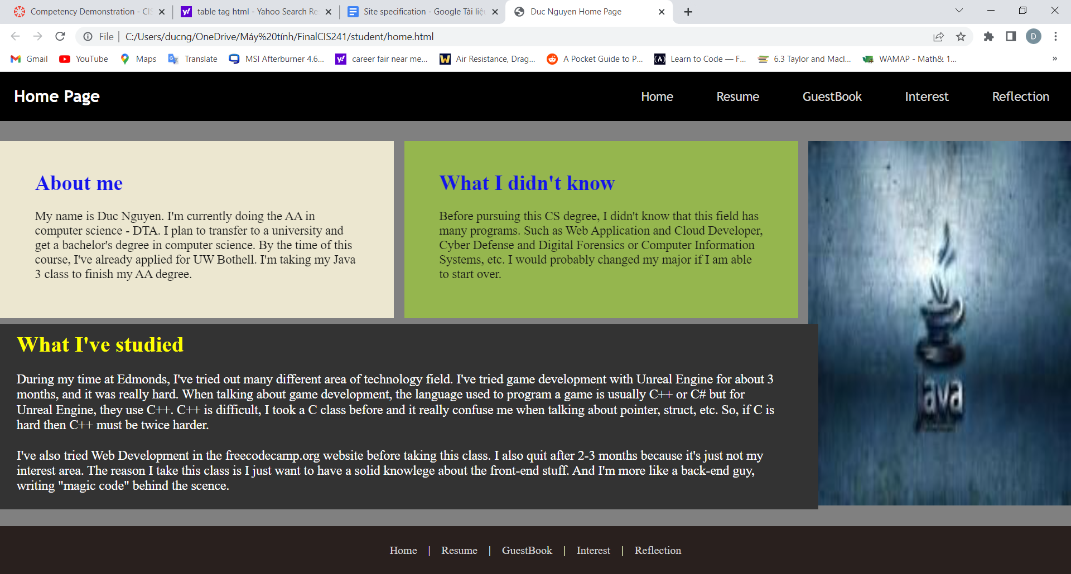

Interest page: Same thing as home page.

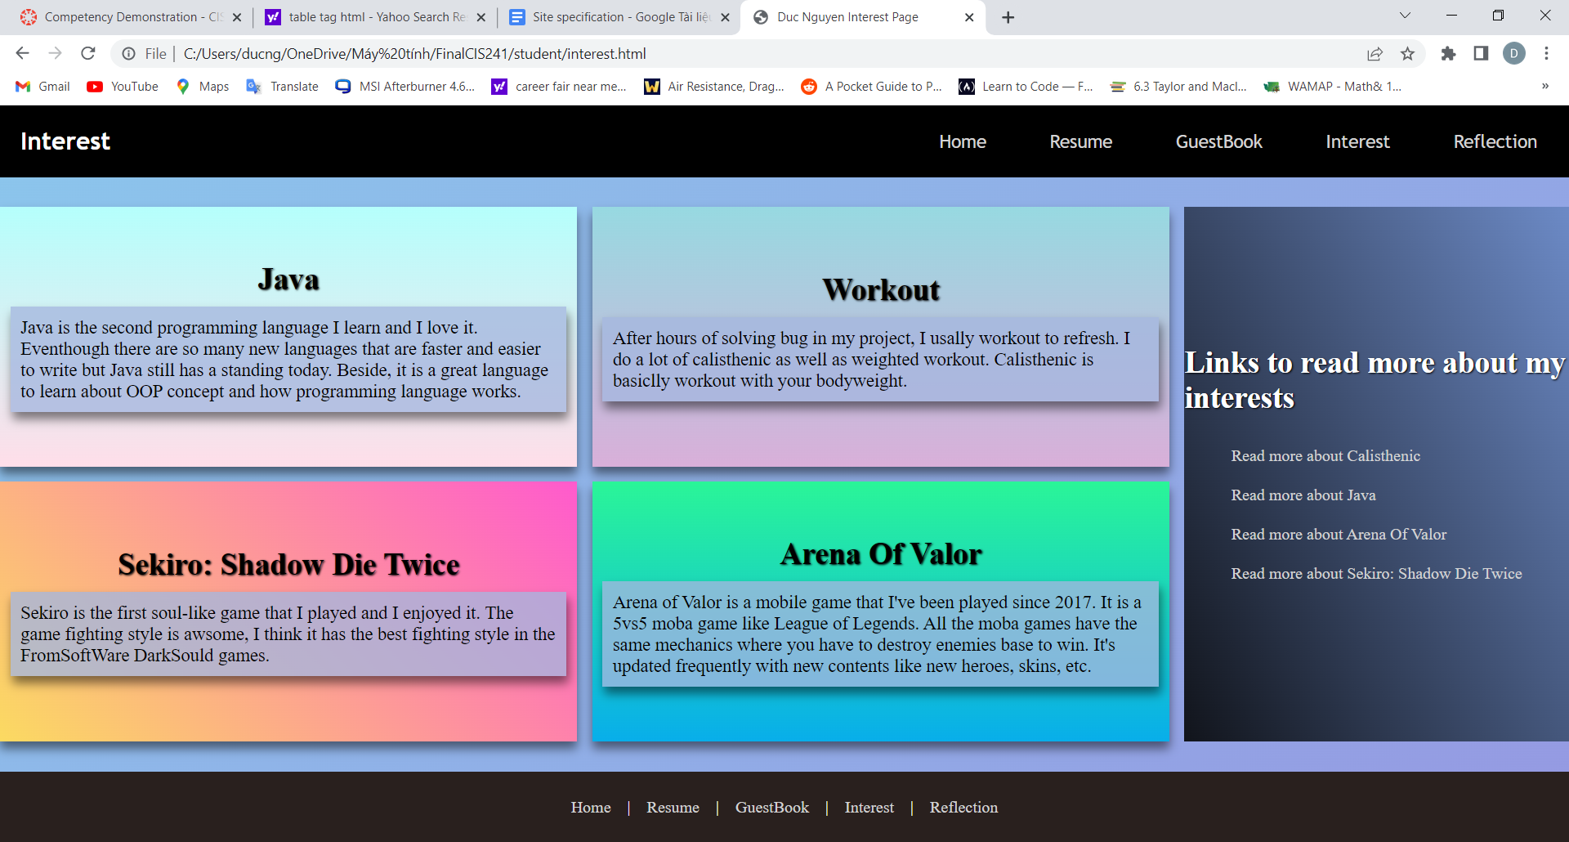

Resume page:

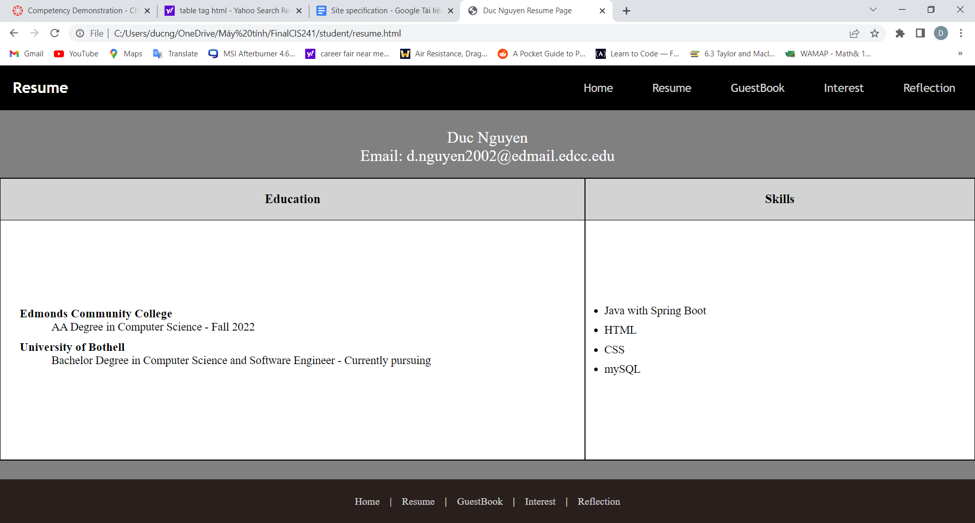

Guesbook page: Have 2 colors blue and yellow constantly move around the border of the form.

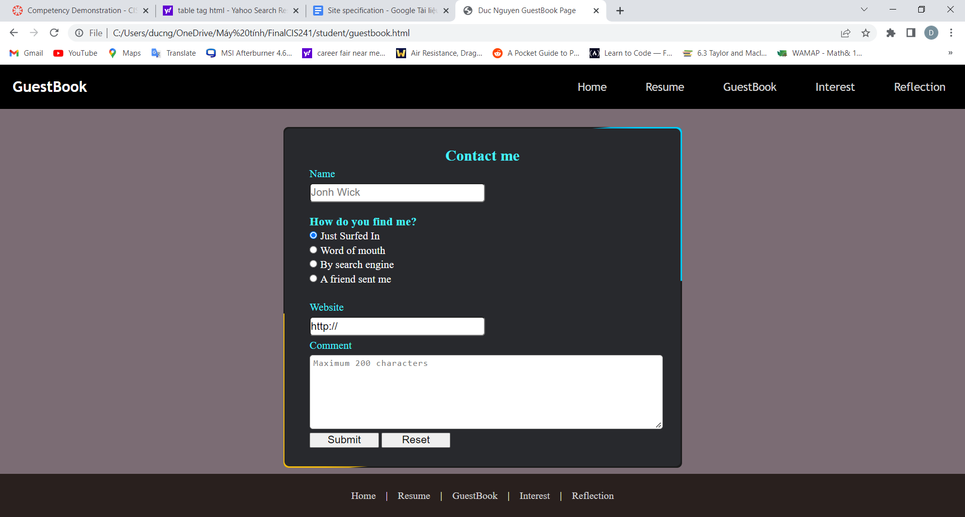

Reflection page:

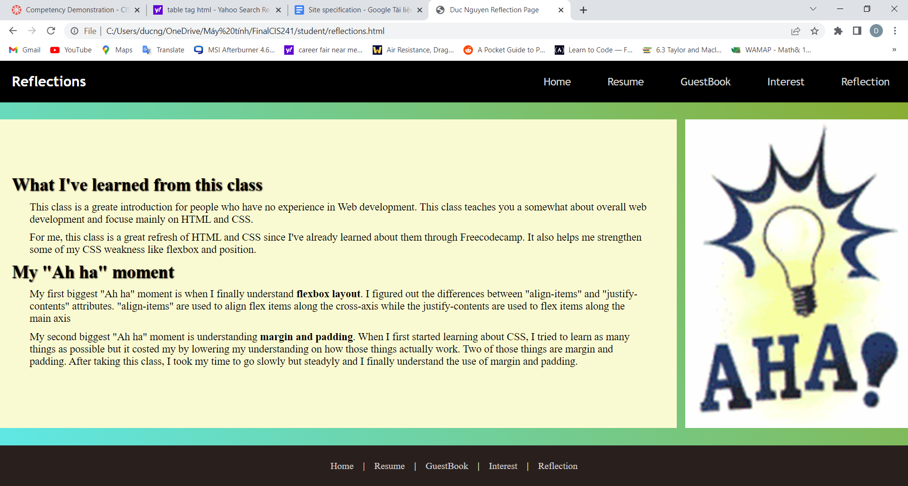

**\*\*Note: I only use media queries on the navigation bar.**